**Title: Sample Title of term paper**

**Author: Sudha Rani Rangapale, Data Engineering**

**MEGI001-210213 - Geo-Information Systems**

**Topic description**

“**Everybody knows that the autumn landscape in the north woods is the land ,plus a red maple ,plus a ruffed grouse.”[Aldo Leopold]**

This project is about estimating the size of ruffed grouse habitat at the Cloquet Forestry Center (CFC) in Carlton County ,Minnesota ,USA. Minnesota is one of the top three states in total ruffed grouse harvest [1].Ruffed grouse are a leading small game species in Minnesota [1] . Aspen Forest type is important high-quality habitat of ruffed grouse .

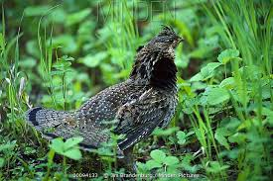

[Image : mindenpictures.com][5]

**General Life History of Ruffed Grouse**

Ruffed Grouse is medium sized bird approximately 15.5 to 19.5 inches in length(Johnsgard 1983) and weight of about 1 to 1.5 pounds (Rusch et al.2000) population is spread over deciduous and coniferous forests of North America[1] .The Breeding period of these species occurs in late March and early April where males undergo their mating ritual called Drumming[1].Ruffed Grouse population density vary among habitats, years and areas. These species are found in forests of South-eastern and North-western Minnesota. Best Habitat for these species are provided by young to middle aged Aspen Forest.

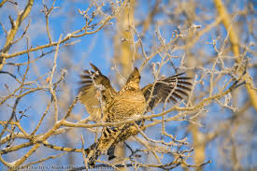

[Image : alaskaphotographics.photoshelter.com][4]

In Northern Minnesota , Gullion (1984a) reported densities of 1.2 to 5.3 drumming males per 100 acres[1]. Ruffed Grouse in riparian forests of Southwestern Minnesota are absent.[3][ruffedGrouseminnesota.com].

From recent study of Minnesota more drumming Grouse are found in young aspen stands and fewer in conifer stands and mature spruce. Ruffed Grouse favour buds and twigs of aspen but also eat fruits of dogwood, mountain ash and thronapple.

These species live most of its life within few acres, and alone except during mating season[1].

**Data and Procedure used**

**Datasets used are :**

Cloquet_roads.shp which consists of road layer.

Cloquet_streams.shp which consists of streams/lake layer.

Cloquet_vegetation.shp which consists of vegetation layer.

Iverson_drg.img which consists of a digital graphic of a USGS 7.5 topographic.

**Resource :** QGIS

**Procedure :**

1. Download data from piggy . Datasets downloaded are Cloquet_roads.shp, Cloquet_streams.shp, Cloquet_vegetation.shp and Iverson_drg.img .
2. Upload all datasets onto QGIS.

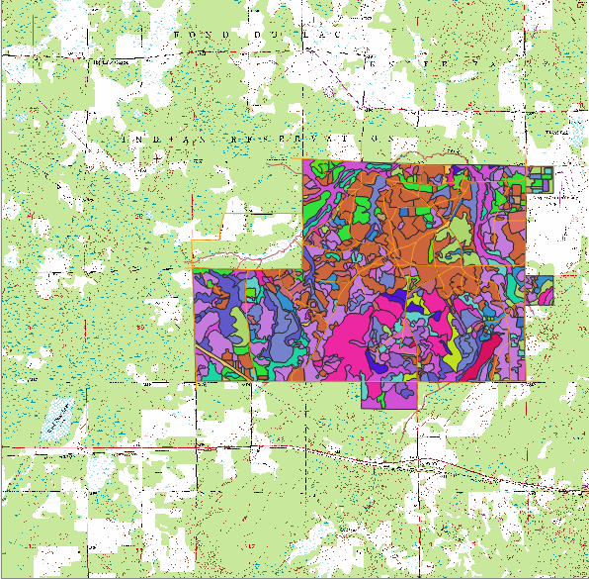

[Image : QGIS ]

1. To find areas that are near aspen/birch ages use vegetation layer to identify Aspen and Birch stand , codes for vegetation layer(C_type) are A and B.
2. Export the stands identified to separate feature layer, naming it AspenBirch.shp., the idea behind creating this layer is that ruffed grouse are usually found on AspenBirch trees stands and mostly on young to middle age tree stands..

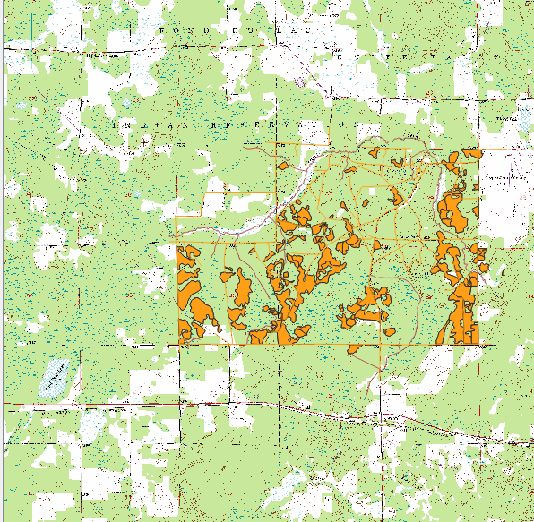

[Image : AspenBirch layer, QGIS]

1. Find age of Aspen and Birch by subtracting establishment year from present year(2019).
2. Select Young ,Intermediate and old tree stands from AspenBirch layer ,exporting each to create three new feature layers.

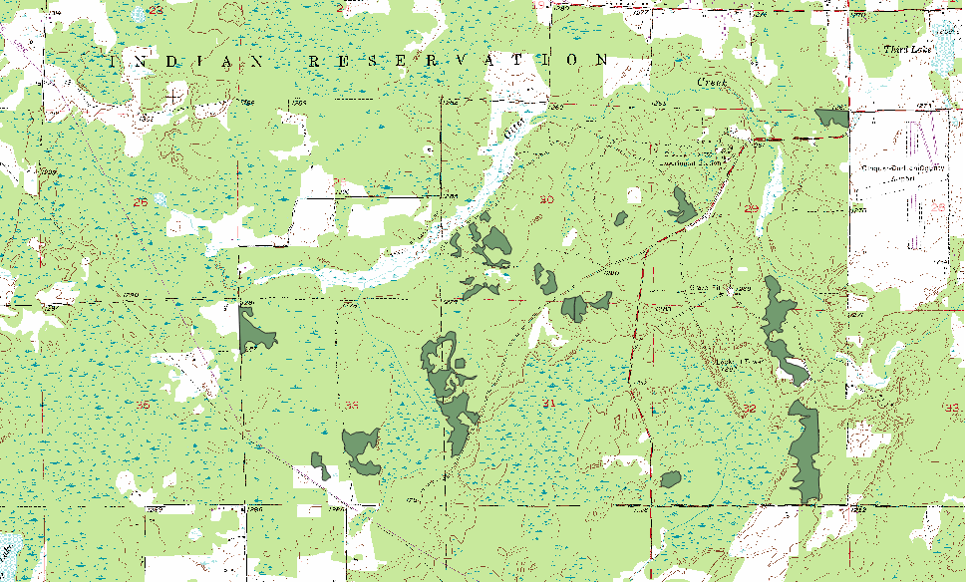

[Image:Young AspenBirch tree stand,QGIS]

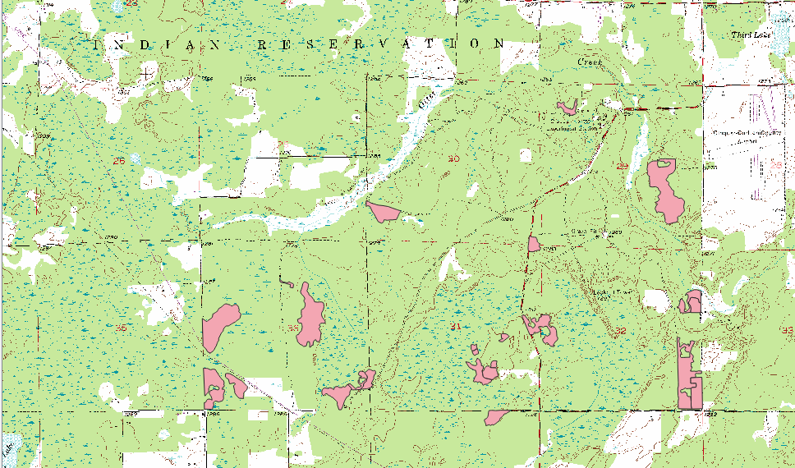

[Image : Intermediate AspenBirch tree stand, QGIS]

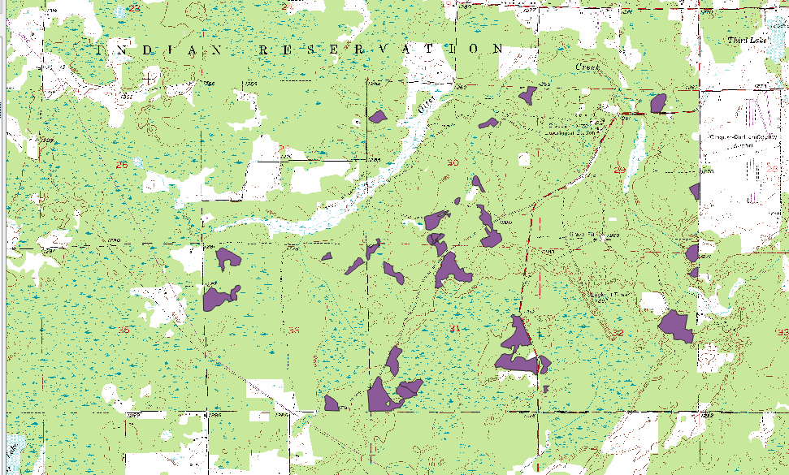

[Image : Old AspenBirch tree stand, QGIS]

1. Retrieved 30 records of old ,25 intermediate and 30 young Aspen tree stands from AspenBirch layer.
2. Buffer Each layer created in previous step to 300 meters and overlay these layers using Intersection command to create a Coverfood layer.

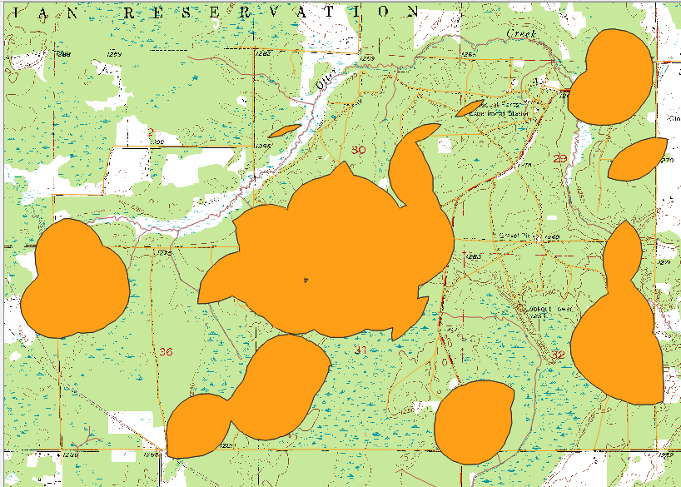

[Image : Coverfood layer , QGIS]

1. Select those records of vegetation layer that are White Pine, Red Pine, Jack Pine, Scotch Pine or White Spruce. Save this layer as Interim and filter this layer that consists of origin > 0 and origin < 1901, export this layer as new feature named Old_conifer layer. We will get 21 records in old conifer layer.

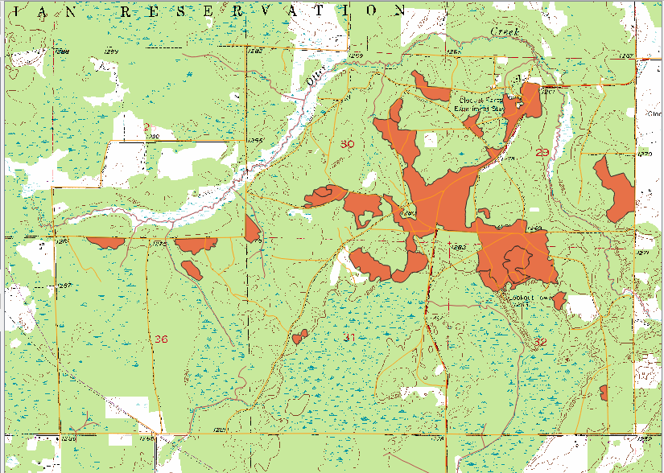

[Image : Old_conifer layer , QGIS]

1. Buffer Old conifer layer to 50 meters to get Adjacent raptor perch area.

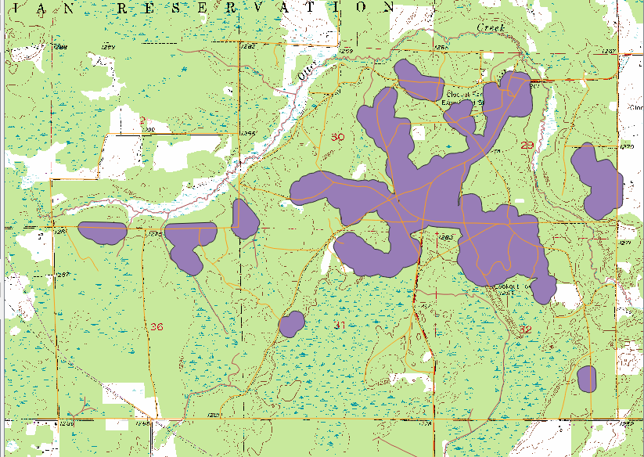

[Image : Adjacent Raptor perch area , QGIS]

1. Erase adjacent raptor perches from cover food layer and it results in prime habitat of Ruffed Grouse.

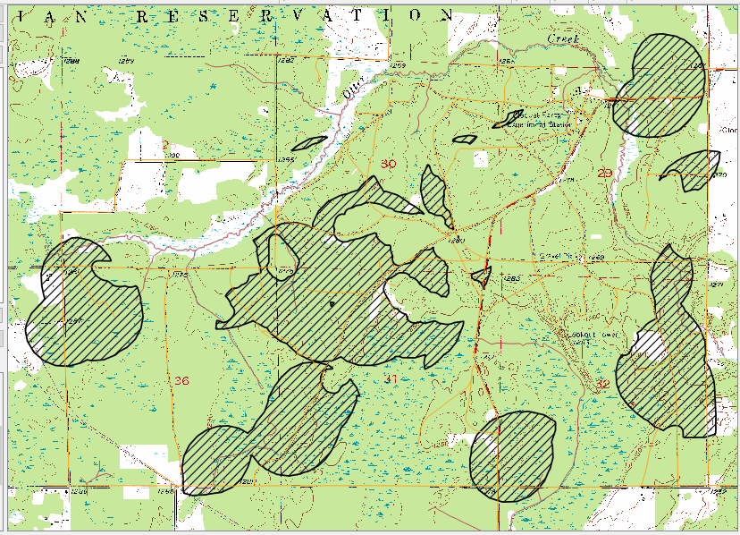

[Image : Habitat of ruffed Grouse, QGIS]

1. Summarize the result to estimate the total size of the ruffed grouse habitat and the summarized result gives mean measurement of 3.504 acres.
2. Final step is producing map with title, North arrow, legend, scale bar and title of map and export it as pdf.

**Results and discussion**

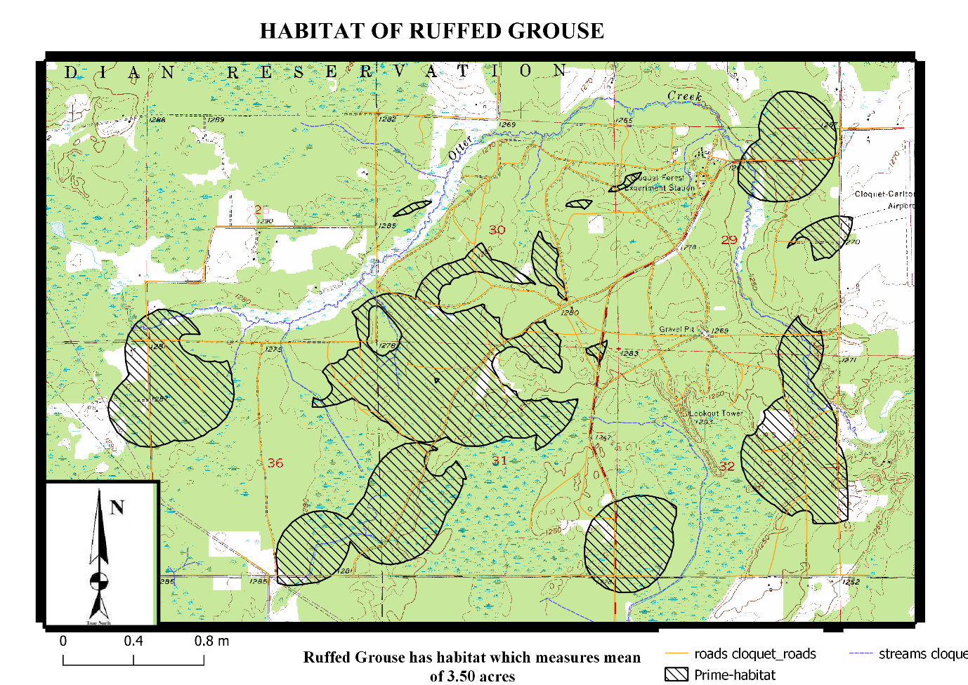

[Image : map of CFC areas with identified areas of high-quality ruffed grouse habitat, QGIS]

This map gives the detailed layout of the habitat of Ruffed Grouse in Minnesota. The polygons or transparent filled layer on the map describe the total size of habitat of this species.

**Difficulties :**

Difficultly in accessing newly created and saved layers, as it was getting deleted every time I open QGIS, tried all ways but have to create layers again and again which took lot of time.

**MEGI001-210103 Introduction to Earth System Data**

**Topic description**

The Goal of this Project and Term paper is about finding a data repository/archive serving vector (points, lines, polygons) data. Searching, selecting, downloading and load/visualise/plot the data.

**Vector data** consists of discrete geometric locations(x, y) known as **vertices** which defines shape of spatial object. The vector data used here is of type line. Line consists of many vertices or points that are connected.[2][earthdatascience.org].

Geospatial vector data are often stored in shapefile format with .shp extension , the file which contains geometry of all features.[2][earthdatascience.org]

**Key metadata** for shapefile includes :[2][earthdatascience.org]

1. Object type : the class of imported file and the class of river_lake_centerlines data is geopandas.geodataframe.GeoDataFrame .
2. Coordinate Reference System : the projection of data ,Projection of our data is espg code 4326.
3. Extent : spatial extent of file

**Data and methods used**

Datasets are downloaded from a public domain map called Natural earth data . The type of data used is vector which comes in ESRI shapefile format with character encoding of UTF-8 and the projection code id ESPG:4326.

10m_physical/ne_10m_rivers_lake_centerlines.shp, the physical vector data theme used here is Rivers and lake Centerlines which includes name and line width attributes. Rivers are primarily derived from World data bank and lake centerlines are obtained by manually drawing connecting segments in reservoirs [naturalearth.com] .

**Resource** : Python

Tool used is Python and the packages used are below :

Shapely is python package for manipulation and analysis of planar geometric objects.[MEGI001-2101033_01-basics]

Pandas is open source library providing high-performance ,easy to use data structures and data analysis tools [pandas.pydata.org]

Geopandas is an open source project to make working with geospatial data in python easier.[geopandas.org]

Matplotlib is a python 2D plotting library using which we can generate plots , histogram ,bar chart etc.[ MEGI001-2101033_01-basics].

**Procedure**

1. Download Natural earth data consisting of River_lake_centerlines .
2. Import required packages like Shapely ,geopandas , Pandas and Matplotlib and set the data path.
3. Load data onto python and crs of data can be checked ,Next plot the data and the data plotted looks like below figure.

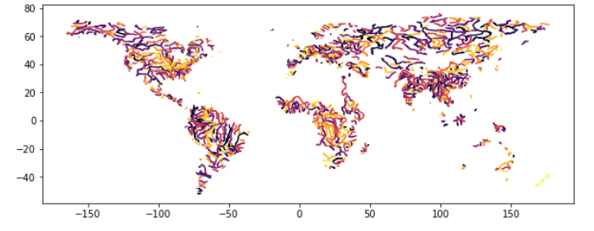

[Image : River_lake_centerline jupyter notebook]

1. Geometry of the data can also be checked .
2. Load world data which can be used as global base layer map.
3. Used GeoDataFrame plot method to overlay world and River_lake_centerline map and customize the styles for each layer.
4. Overlay of Both layers look like

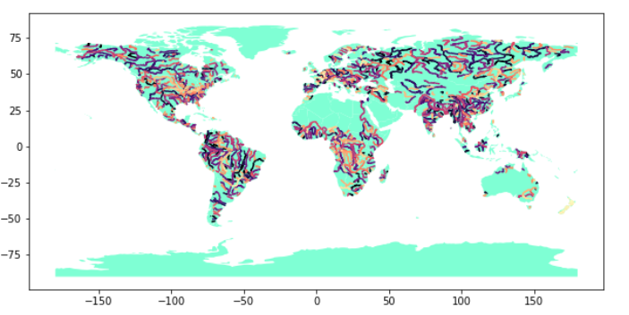

[Image : Overlay of world and river_lake_centerlines layers , jupyter notebook]

1. Complete code and output can be found be in github page, Link has been listed in Links and Repository section below[0].

**Results and discussion**

Visualization of Vector data River_lake_centerlines of world on the world base map.

**Difficulties:**

Firstly, finding data was difficult due to shutdown of many sites. Chose natural Earth data as it is open source and easy to download the data.

**Links to repos/files**

[0] <https://github.com/srangapale/Termpaper.git>

**References**

[1] <http://files.dnr.state.mn.us/recreation/hunting/grouse/rgmp.pdf>

[2][https://www.earthdatascience.org/courses/earth-analytics-python/spatial-data-vector- shapefiles/intro-vector-data-python/](https://www.earthdatascience.org/courses/earth-analytics-python/spatial-data-vector-%20%20%20%20%20shapefiles/intro-vector-data-python/)

[3] <http://www.ruffedgrouseminnesota.com/ruffed-grouse-in-minnesota/>

[4]https://alaskaphotographics.photoshelter.com/image/I0000_PdzF6NvMBY [5] [5]<https://www.mindenpictures.com/search/preview/ruffed-grouse-bonasa-umbellus-displaying-in-undergrwothminnesota/0_00094133.html>